**GCC Assignment**

1. Logging into linux server

1. To compile code “gcc code.c” command is used.



1. To execute the file “./a.out” command is used



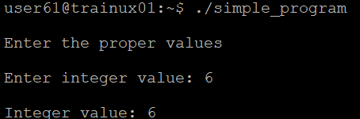



|  |  |
| --- | --- |
| Executable Files | Object Files |
| This is the final output of the compilation, and it can be executed directly. | This is an intermediate file generated from the source code and is not executable by itself. It contains compiled code but lacks the full linking. |













